Mechanics 2 Aide Memoire

Work done – measured in Joules
Energy lost due to overcoming a force (no work done if force acts perpendicular to the direction of motion)

Work done = 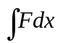 or Fx for a constant force, F over a distance, x.

= Area under a force/distance graph

= 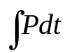 or Pt for constant power, P over t seconds

= change in kinetic energy

Power – measured in Watts
The rate at which work is done

Power = Force x Velocity

= d (work done)
dt

IMPORTANT – At maximum or constant velocity, no acceleration so forces are balanced.

Example 1

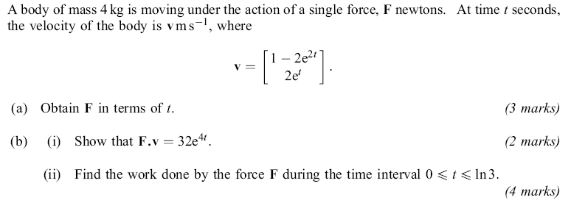

Solution

a) a = dv = -4e^{2t}
dt 2e^{t}

Using F = ma gives F = 4 -4e^{2t} = -16e^{2t}
2e^{t} 8e^{t}

b) i) F.v = -16e^{2t} . 1 - 2e^{2t} = -16e^{2t} + 32e^{2t}e^{2t} + 16e^{t}e^{t}
8e^{t} 2e^{t}
= -16e^{2t} + 32e^{4t} + 16e^{2t}

= 32e^{4t}

ii) F.v = Power Work done = ∫Power dt

= ∫32e^{4t} dt

= 8e^{4t}

= 648 – 8

= 640J

Example 2

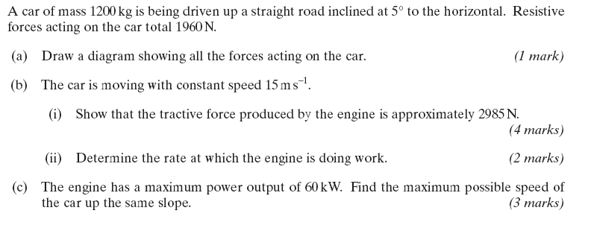

Solution

a)
5⁰
1200g
Tractive
Force, T
resistive
forces
1960N
R
b) i) Constant velocity so no acceleration i.e. forces are balanced

Resolving along the plane T = R + 1200gsin5º

T = 1960 + 11760sin5º

T = 2985 N ( 4 sig. figs.)

ii) Rate of doing work = Power

= Force x Velocity

= 2985 x 15 (force used is tractive force as we want the power of the engine)
= 44775 W

c) At maximum speed, no acceleration i.e. forces are balanced so T = 2985 N

Power = Force x Velocity

60000 = 2985v

v = 20.1 ms⁻¹

Conservation of Energy – energy is conserved unless work is done. In these cases energy lost = work done

There are 3 main types of energy at this level

- Potential energy (P.E.) – mass x acceleration x height
- Kinetic energy (K.E.) - ½ x mass x (velocity) ²
- Elastic Potential Energy (E.P.E) - ½ x spring constant x (extension) ²
N.B. spring constant, k = modulus, λ / natural length, l
λ measured in N; k measured in Nm⁻¹

Example

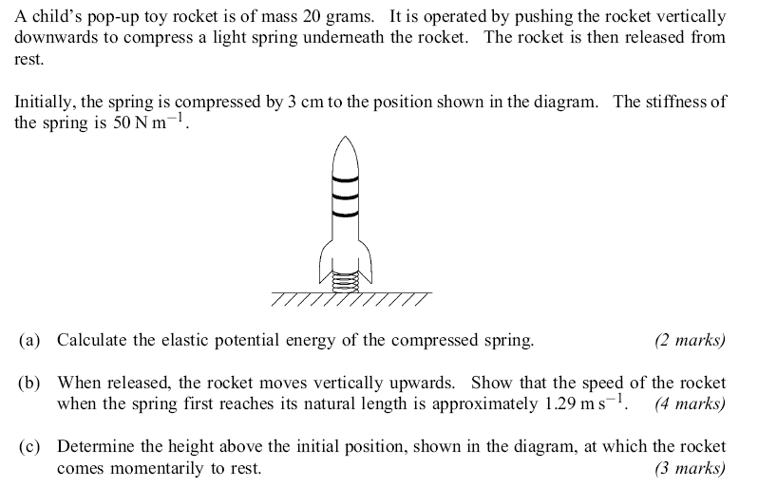
Solution

a) E.P.E. = ½ x 50 x 0.03² = 0.0225 J

b) When spring reaches natural length (3cm) from start, no EPE (just KE and PE)
Conservation of Energy gives:

0.0225 = ½ x 0.02 x V² + 0.02 x 9.8 x 0.03
V² = 1.662
V = 1.29 ms⁻¹ (3 s. f.)

c) Rocket comes to rest at highest point. Stationary so no KE, spring is not stretched or compressed so no EPE.
All energy is PE
Conservation of Energy gives:

0.0225 = 0.02 x 9.8 x h (h = height above start position)
h = 11.5 cm (3 s. f.)

Centre of Mass – the place where all the mass of an object appears to act.
A uniform lamina has an equal mass per unit area throughout the lamina.
Basically nothing more complicated than finding the ‘resultant moment’.
For a uniform shape, the centre of mass lies on the line(s) of symmetry.
If a shape is freely suspended, the centre of mass will always be directly below the point it is suspended from.

Example
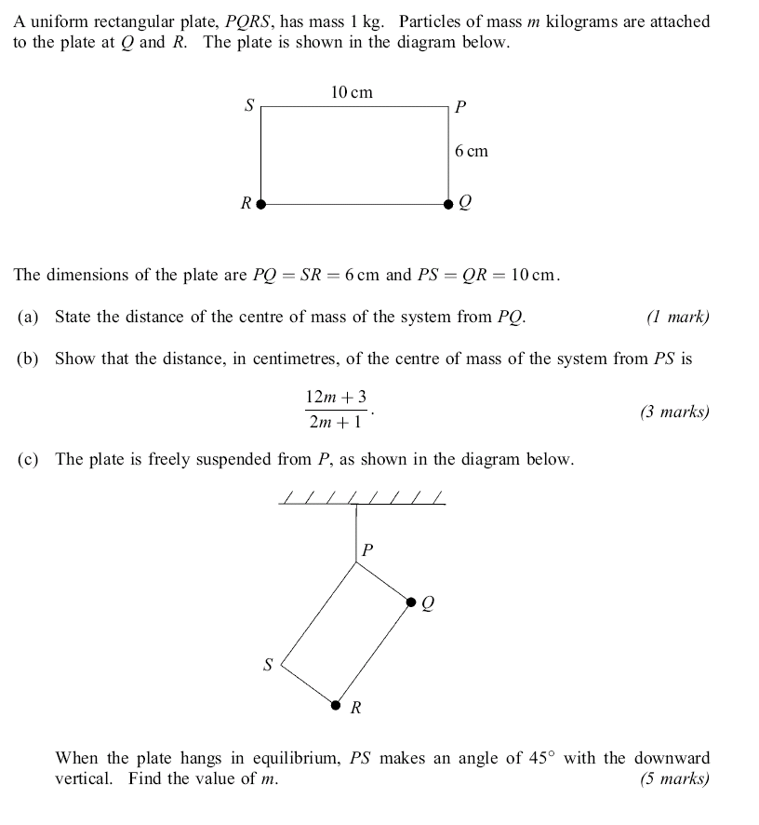
Solution

a) By symmetry, centre of mass is 5 cm from PQ.

b) Taking moments from PS, moments due to 2 masses and plate must be equivalent to the moment due to the total mass acting at the centre of mass, a distance x from PS.

6 x m + 6 x m + 3 x 1 = (2m+1)x

12m + 3 = (2m+1)x

x = 12m+3 (as required)
2m+1

c) When freely suspended, centre of mass will be directly below the suspension point.
5cm
12m+3
2m+1
centre of
mass

tan 45⁰ = 5 x (2m+1)
12m+3

12m +3 = 10m +5

2m = 2

m = 1 kg

Example

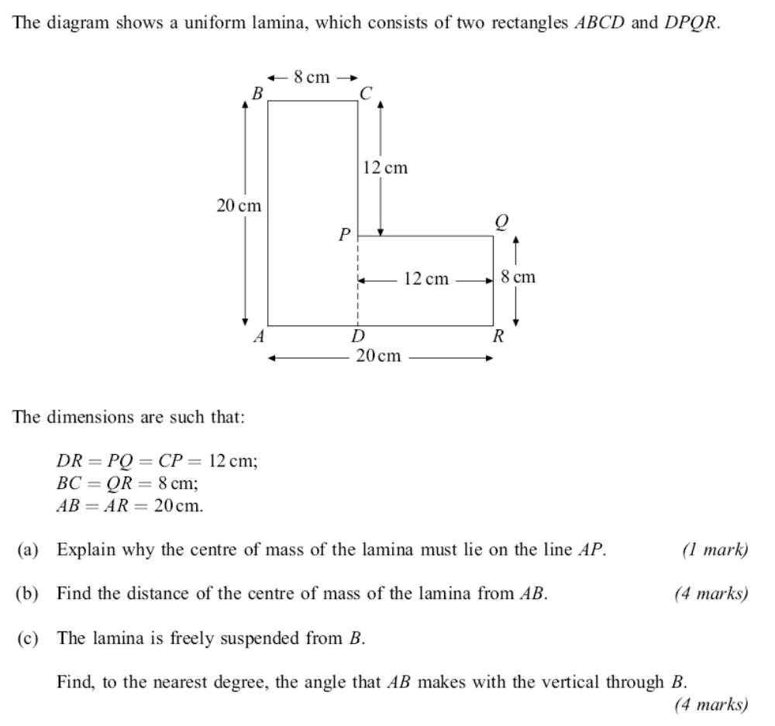
Solution

a) Centre of mass must be on AP because it is the line of symmetry of a uniform shape.

b)
A
Centre of mass
160g
96g
256g
4
x
14
B
Mass is determined by area
Turning force due to centre of mass = turning forces due to individual centres of mass

Using moments 160g x 4 + 96g x 14 = 256gx

x = 7.75cm

c) Lamina is freely suspended, so centre of mass will be below B.
B
Centre of mass
θ
7.75cm
12.25 cm
tan θ = 12.25
7.75

so θ = 57.7° (to 3 sig. fig.)

Horizontal circular motion

Any particle moving in a circular orbit has a constantly changing velocity (direction it is moving in changing). This means that there is an acceleration and therefore a resultant force. The acceleration and resultant force are directed towards the centre of the circular path.

v = rω ‘v’ is velocity, ‘r’ is radius, ‘ω’ is angular speed (rad s⁻¹)

acceleration, a = v² = rω²
r

resultant force = ma = mv² = mrω² (directed towards the centre of the circle)
r

IMPORTANT FACT – the resultant force is not an additional force, it is the resultant of all the forces present.

Example

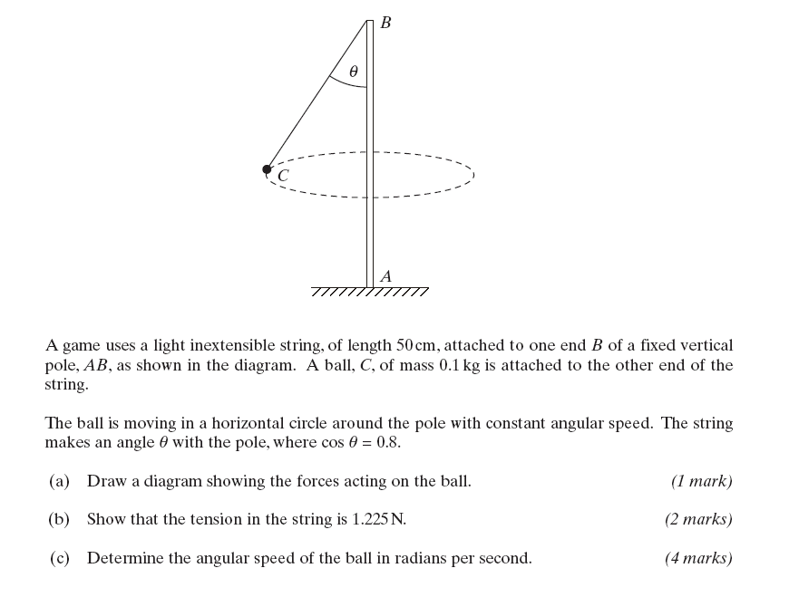

Solution

a)
0.1g
T
θ

b) Resolve vertically

Particle is not moving vertically so:

0.1g = Tcosθ and cosθ = 0.8

so T = 0.1g = 1.225 N (as required)
0.8

c) Resolve horizontally (should be a resultant force towards the centre)

Tsinθ = mrω²

sinθ = r so 1.225 x r = 0.1 x r ω²
0.5 0.5

ω² = 24.5

ω = 4.95 rad s⁻¹ (3 s. f.)

Example

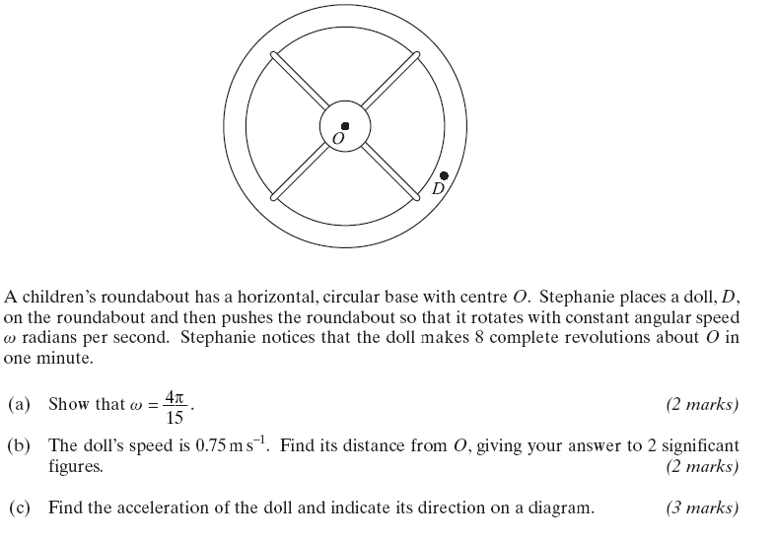

Solution

a) One revolution = 2π radians
so 8 revolutions per minute = 16π radians per minute
16π radians per minute = 16π radians per second
60

= 4π radians per second (as required)
15

b) Using v = rω r = v
ω

r = 0.75 x 15 = 0.8952….. = 0.90 metres (2 sig. fig.)
4π

c) Using a = v² ( or a = rω² ) gives a = 0.63 ms⁻² ( 2 sig. fig.)
r directed towards the centre of the roundabout

Vertical Circular Motion

The major difference in the mechanics of vertical and circular motion is that in vertical circular motion, the resultant force towards the centre (and hence the velocity and acceleration) are constantly changing. However if we look at ‘snapshots’ of the motion all the principles and equations relating to horizontal circular motion will still be valid.
Particle is at its fastest at the bottom of its circular path and slowest at the top.
Vertical circular motion questions often involve a number of other principles such as conservation of energy. They are usually worth a large number of marks.

Example

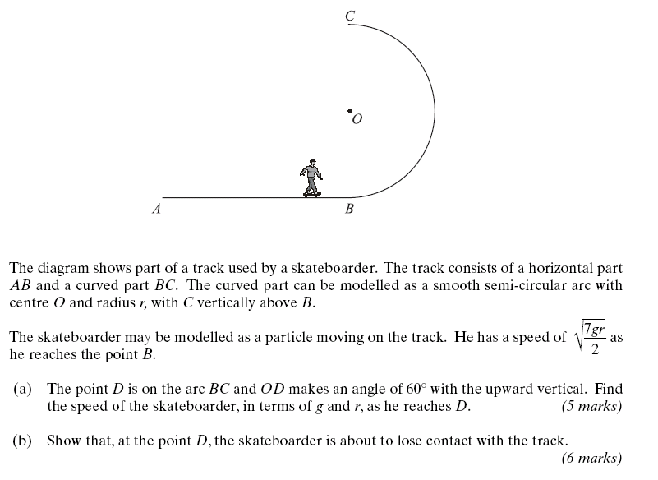
Solution

a) Draw diagram

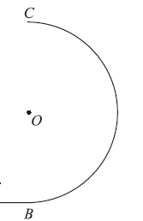
r
mg
60
R
D

This is an energy question. We know the speed at B and that the track is smooth (no work done against friction) so energy is conserved.

Energy at B (all K.E.) = ½ mx 7gr = 7mgr Joules
2 4 vertical height of D above B

Energy at D (mixture of K.E. and P.E.) = 1 mv² + mg(r + rcos60)
2

Using C. of E. 7mgr = 1 mv² + mg(r + rcos60)
4 2

7gr = 2v² +4g(r + rcos60) remember cos60 = ½

7gr = 2v² + 12gr = 2v² + 6gr
2
2v² = gr

v = 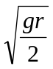

b) Now for the vertical circular motion part.
We need to resolve towards the centre and show that the Normal Reaction force is zero (i.e. no contact between skater and track).

Resolving towards O gives:

R + mg cos60 = mv² (just like horizontal circular motion)
r

but v =
so R + mg = mgr
2 2r

R + mg = mg
2 2

R = 0 (as required)

Example

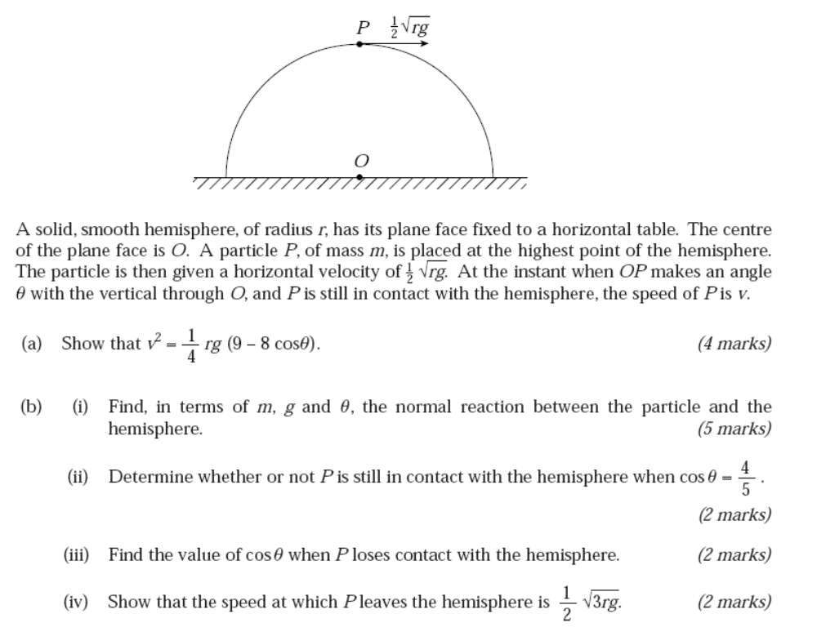

Answer

a) Using Conservation of Energy

Energy at top (K.E. and P.E.) = 1m x 1rg + mrg
2 4

= 9mrg vertical height above base
8

Energy ‘on side’ (K.E. And P.E.) = 1mv² + mg rcosθ
2

Equating gives: 9mrg = 1mv² + mgrcosθ
8 2

v² = 9rg – 2grcosθ
4

v² = 1rg (9 – 8cosθ) (as required)
4
b) i) Diagram
v² = 1rg (9 – 8cosθ)
4
mg
R
θ
Circular motion question – resolve towards the centre

mgcosθ - R = mv²
r
mgcosθ - R = mrg(9 – 8cosθ)
4r

R = mgcosθ - mg(9 – 8cosθ)
4

R = 3mgcosθ – 9mg
4

R = 3mg(cosθ - 3)
4

ii) when cosθ = 4 R = 3mg ( 4 - 3 )
5 5 4

R = 3mg R is positive so particle still in contact
20 with hemisphere.

iii) When P loses contact with hemisphere there will be no reaction force i.e. R = 0

0 = 3mg(cosθ – 3)
4

cosθ = 3
4

θ = 41.4º (3 sig. fig.)

iv) Using v² = 1rg (9 – 8cosθ) and cosθ = 3
4 4

v² = 1rg (9 – 8x3)
4 4

v² = 3rg
4

so v = 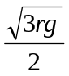 (as required)

